PDS Assignment
Mark: 8.5
Insight missing

library(readxl)
library(dplyr)
library(cowplot)
library(ggplot2)

#Reading the excel file
stu = read_excel("D:/Study/MBA 1st Sem/PDS/R Programming/StudentsPerformance.xlsx")
View(stu)
#no. of rows
nrow(stu)

#The below function will add all data from stu and a new column named average_score to stu_new with values computed
stu_new = mutate(stu,average_score = round((math_score+reading_score+writing_score)/3))
stu_new$average_score
head(stu_new)

#The below function will calculate aggregate of math scores and will group by group no
math_score_aggregate = aggregate(stu_new$math_score, list(stu$group), FUN=mean)
math_score_aggregate

#The below function would create a bar chart of average math score and separate by groups
plot1 = ggplot(math_score_aggregate, aes(x=group, y=avg_math_score, fill=group)) + geom_bar(stat="identity") +
labs(x="Groups", y="Average_Math_Score")
plot1
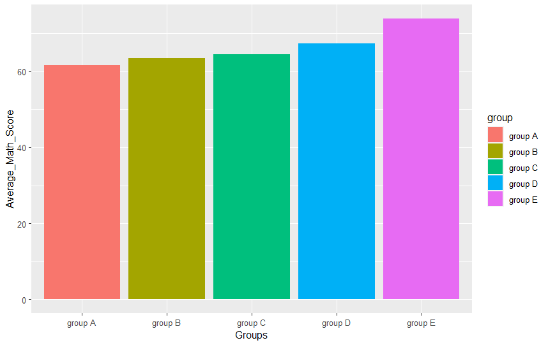

#The below function would create a box plot keeping group in x axis and total marks in y-axis and store it in total_box
total_box=ggplot(total_stu, mapping=aes(x=group, y=total_mark, fill=gender))+geom_boxplot()
total_box
